**Day 1:**

1.Sematic Tags and non-semantic tags

2.Backward navigation

3.Sign up and sign in form

**Day 2:**

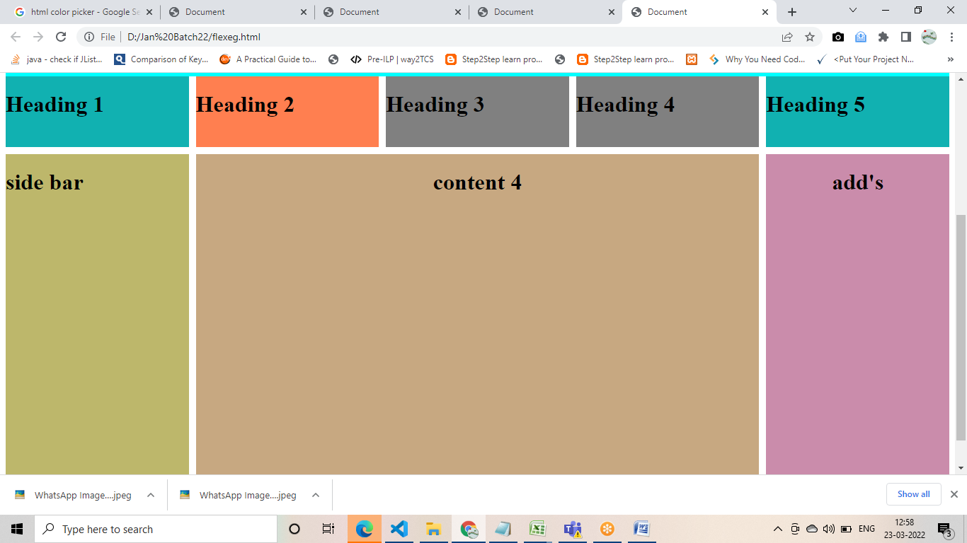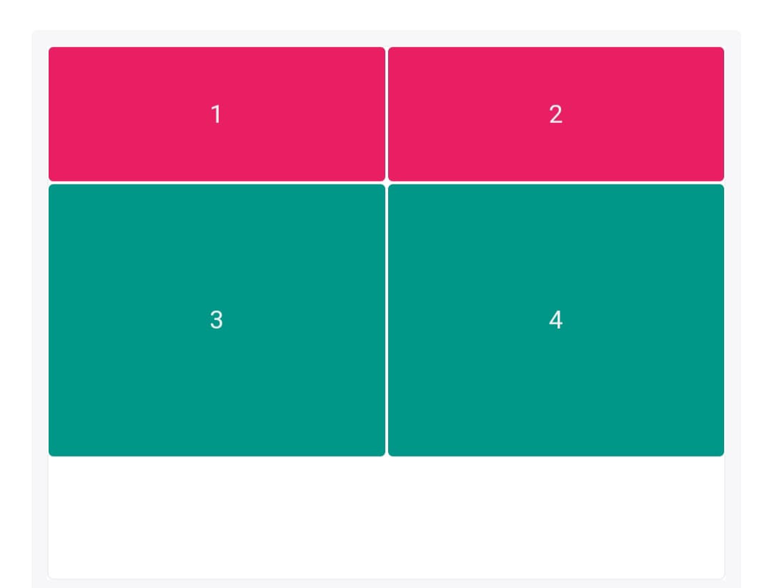

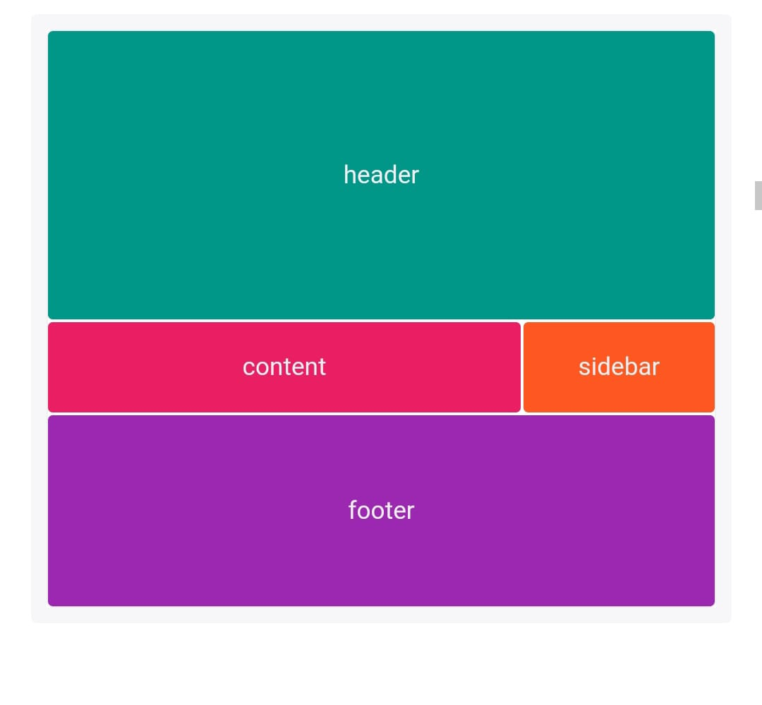

4.Create Web page for an organic store / portfolio using box model (using CSS properties and box model)